Tittle of Activity
To-Do List API + UI

Group Members
Abreu, Xyrill John F.
Balatayo, Brielle Edrian A.
Gonzales, Michael Rhoi L.
Ibarra, Kenneth Gene

Subject
ITEC 116 – System Integration and Architecture

Objective
The main objective of this activity is to develop a simple and responsive To-Do List web application that allows users to add, view, update, delete, and mark tasks as completed, using React for frontend, Node.js for the backend API, and MySQL for data storage.

System Overview
The system is composed of three main parts:
- Frontend (React): Displays tasks and interacts with users.
- Backend (API): Handles requests (GET, POST, PATCH, DELETE) between frontend and database.
- Database (MySQL): Stores all the task data.

Features
- Add new tasks
- Delete Tasks
- Mark Tasks as completed (with checkbox)
- View task list dynamically
- Responsive Design

Technologies Used
Objective | Objective
Frontend | React.js
Backend | Node.js, Nest.js
Database | MySQL
Styling | CSS
Tools | VS Code, XAMPP, GitHub

Installation and Setup
Step 1 – Clone Repository
git clone https://github.com/skyana-08/ITEC116

Step 2 – Backend Setup
cd backend
npm install
npm start

Step 3 Frontend Setup
cd frontend
npm install
npm start

Step 4 – Database Setup
Import the Database file in your database.

Output Screenshots
Home Page
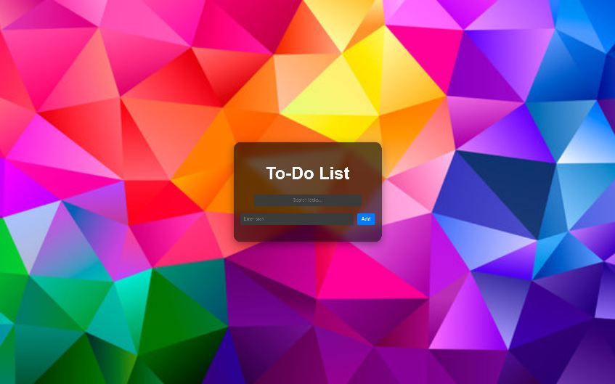

Task Added
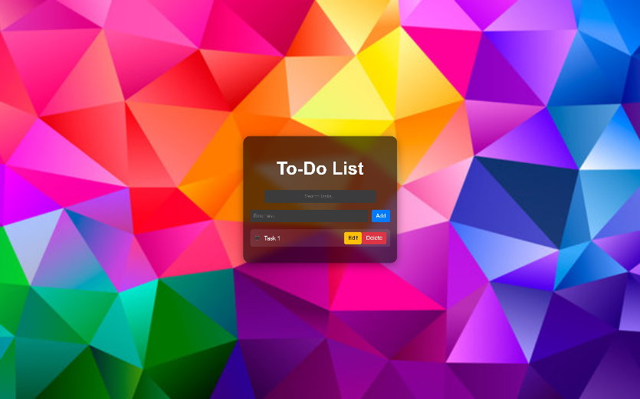

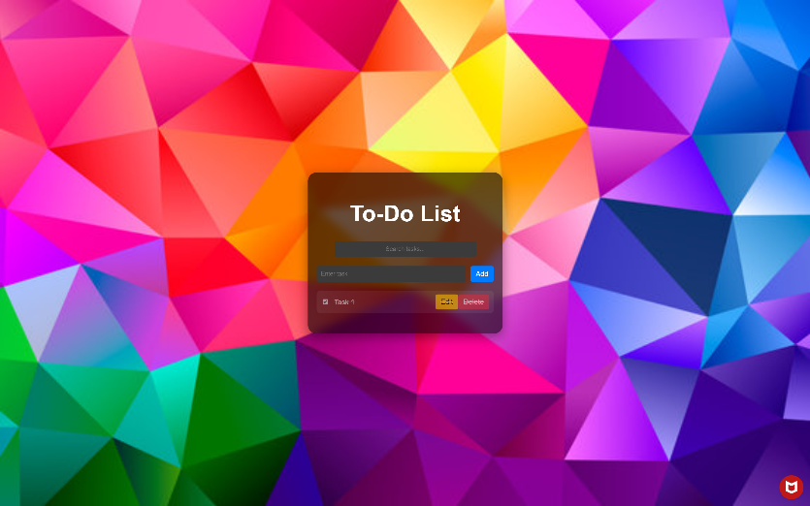
Task Completed

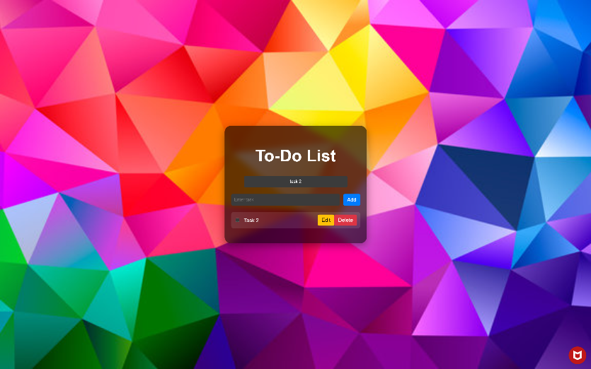
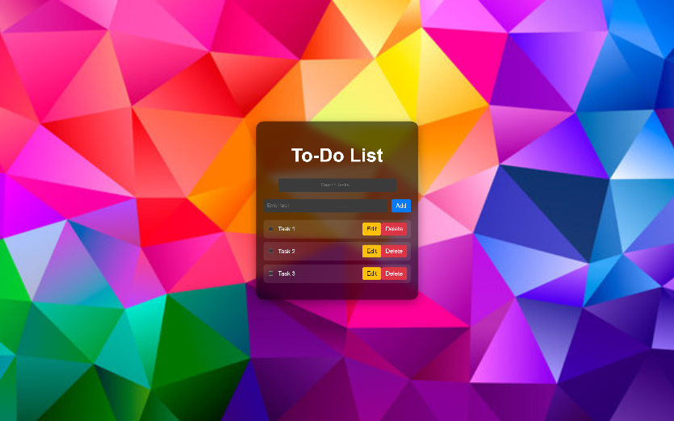
Task Searching

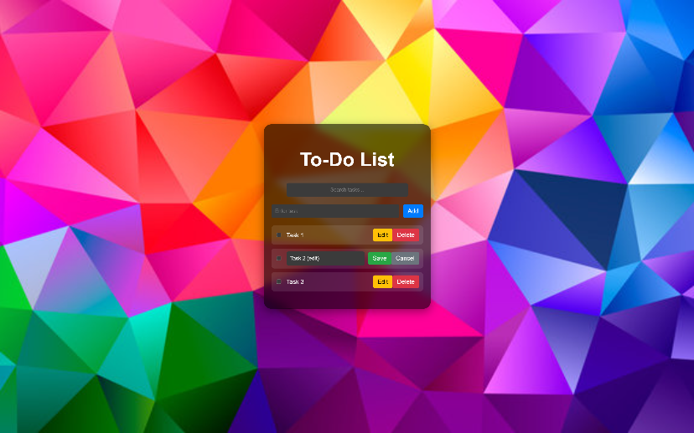
Task Editing
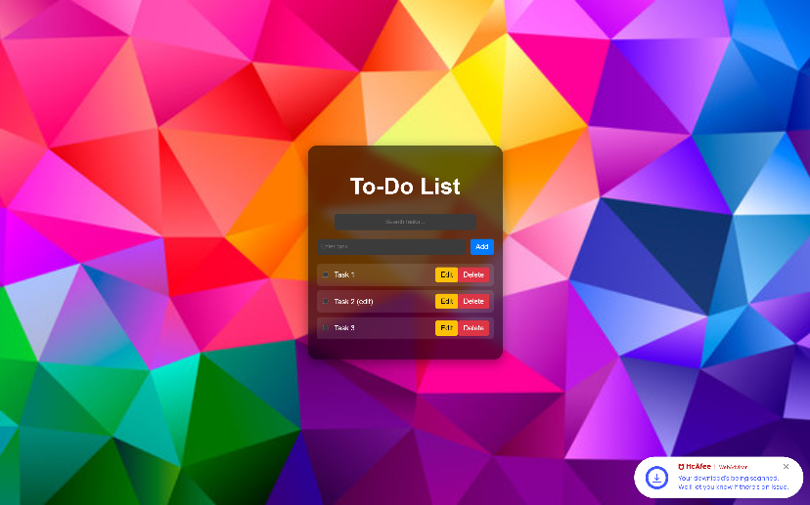

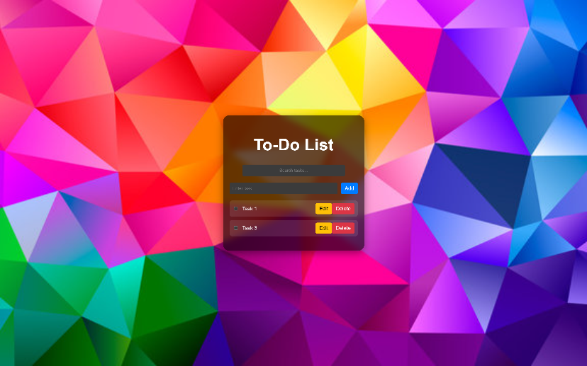
Task Deletion

Sample Code
import React, { useEffect, useState } from "react";

function App() {
const [tasks, setTasks] = useState([]);
const [newTask, setNewTask] = useState("");
const [editingId, setEditingId] = useState(null);
const [editedTitle, setEditedTitle] = useState("");
const [searchTerm, setSearchTerm] = useState("");

useEffect(() => {
fetchTasks();
}, []);

const fetchTasks = async () => {
try {
const res = await fetch("http://localhost:3000/tasks");
const data = await res.json();
setTasks(data);
} catch (err) {
console.error("Failed to fetch tasks:", err);
}
};

const addTask = async () => {
if (!newTask.trim()) return;
await fetch("http://localhost:3000/tasks", {
method: "POST",
headers: { "Content-Type": "application/json" },
body: JSON.stringify({ title: newTask, completed: false }),
});
setNewTask("");
fetchTasks();
};

const deleteTask = async (id) => {
await fetch(`http://localhost:3000/tasks/${id}`, { method: "DELETE" });
fetchTasks();
};

const toggleComplete = async (id, completed) => {
await fetch(`http://localhost:3000/tasks/${id}`, {
method: "PATCH",
headers: { "Content-Type": "application/json" },
body: JSON.stringify({ completed: !completed }),
});
fetchTasks();
};

const startEdit = (task) => {
setEditingId(task.id);
setEditedTitle(task.title);
};

const cancelEdit = () => {
setEditingId(null);
setEditedTitle("");
};

const saveEdit = async (id) => {
await fetch(`http://localhost:3000/tasks/${id}`, {
method: "PATCH",
headers: { "Content-Type": "application/json" },
body: JSON.stringify({ title: editedTitle }),
});
setEditingId(null);
setEditedTitle("");
fetchTasks();
};

// 🔍 Filter tasks based on search term
const filteredTasks = tasks.filter((task) =>
task.title.toLowerCase().includes(searchTerm.toLowerCase())
);

return (
<div style={appStyle}>
<div style={cardStyle}>
<h1>To-Do List</h1>

<div style={searchBarStyle}>
<input
type="text"
style={searchInput}
placeholder="Search tasks..."
value={searchTerm}
onChange={(e) => setSearchTerm(e.target.value)}
/>
</div>

<div style={inputContainer}>
<input
style={inputStyle}
value={newTask}
onChange={(e) => setNewTask(e.target.value)}
placeholder="Enter task"
/>
<button style={addButton} onClick={addTask}>
Add
</button>
</div>

<ul style={{ listStyle: "none", padding: 0 }}>
{filteredTasks.map((task) => (
<li key={task.id} style={taskStyle(task.completed)}>
<div
style={{
display: "flex",
alignItems: "center",
gap: "10px",
flex: 1,
}}
>
<input
type="checkbox"
checked={task.completed}
onChange={() => toggleComplete(task.id, task.completed)}
/>
{editingId === task.id ? (
<input
style={{
...inputStyle,
flex: 1,
marginRight: "10px",
fontSize: "14px",
}}
value={editedTitle}
onChange={(e) => setEditedTitle(e.target.value)}
/>
) : (
<span>{task.title}</span>
)}
</div>

{editingId === task.id ? (
<>
<button style={saveButton} onClick={() => saveEdit(task.id)}>
Save
</button>
<button style={cancelButton} onClick={cancelEdit}>
Cancel
</button>
</>
) : (
<>
<button style={editButton} onClick={() => startEdit(task)}>
Edit
</button>
<button
style={deleteButton}
onClick={() => deleteTask(task.id)}
>
Delete
</button>
</>
)}
</li>
))}
</ul>
</div>
</div>
);
}

export default App;

